I wish to determine how the concentration of iodine in water affects the amount of time it takes for it to diffuse through a membrane.

In this experiment I will use various concentrations of iodine in a distilled water solution. After I mix my solutions with different concentrations of iodine I will measure how much time it takes for iodine to diffuse through a membrane by using a starch solution as an indicator to show when the iodine has diffused through the membrane. In this experiment, my independent variable is the different concentrations of iodine in distilled water and my dependent variable is how much time it takes for the iodine to diffuse through a membrane.

I hypothesize that the higher the concentration of iodine in a solution, the faster the iodine will diffuse through a membrane.

There are seven variables that I see that can affect the results of this experiment. Therefore, I must control these variables to limit their influence on the data I intend to collect. To effectively control these variables, I must do the following:

* Iodine
  + For each trial and iteration, I will use the same iodine as my solute in the solution to eliminate this variable.
* Water
  + I will be using distilled water as my solvent to eliminate unwanted contaminates in my iodine-water solution. As well, I will use a constant amount of 20 mL of water to eliminate iodine to water concentration.
* Beginning of Diffusion
  + I will put the sealed semi-permeable membrane (dialysis tube) in the iodine solutions at the same time to prevent one iteration beginning first than another.
* Starch Indicator
  + I will use the same starch indicator solution as my indicator. It will be kept constant through the course of the experiment.
* Beakers
  + The same beakers will be used and will be thoroughly washed between all trials and iterations to eliminate as much random error as possible.
* Surrounding Environment (Ex: air pressure, temperature, etc.)
  + The environmental conditions will be maintained at constantly as possible throughout the course of the experiment.
* Data Recording
  + I will be performing all the data measuring to keep a constant amount of random error.

The experiment will proceed as follows. I will put the starch solution in a semi-permeable membrane (dialysis tube). After doing this, I will mix the iodine solute into my distilled water solvent and create an iodine-water solution at a 2.5%, 5.0%, 7.5%, 10%, and 12.5% iodine to water solution. After doing this, I will submerge my membrane containing the starch indicator into the iodine-water solutions and measure how much time it takes for the starch indicator to indicate the presence of iodine that has diffused through the membrane.

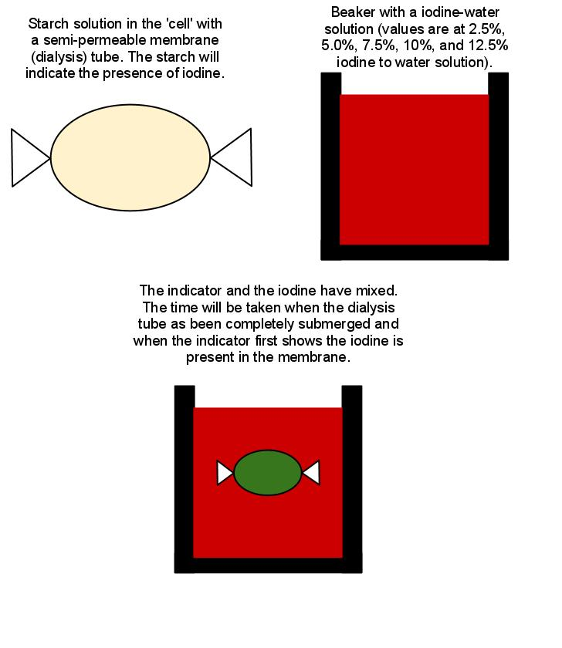

*Not drawn to scale*

I will repeat this experiment for five iterations before beginning the next trial. Each successive trial will increase the amount of iodine mixed into the distilled water solvent by 0.5 mL, and each trial will have five iterations. The experiment will be concluded when five trials are completed.

Materials Used:

* Dialysis Tube
  + Used for the semi-permeable, fluid membrane.
* Distilled Water
  + This will be the solvent in the iodine-water solution
* Iodine
  + Solute in the iodine-water solution
* 100 mL beaker
  + Will have the iodine-water solution and will contain the dialysis tubing.
* 100 mL graduated cylinder
  + Used to fill the beaker with 20 mL of water and the desired iodine amount
  + (must have 1 mL increments)
* Starch Solution
  + Used as an indicator for the presence of iodine.
* String
  + To seal off the ends of the dialysis tubing
* Stirring rod
  + To mix the iodine and distilled water

|  |  |  |  |  |  |
| --- | --- | --- | --- | --- | --- |
| **Trial** | **Iodine Volume** IV / mL∆V = ± 0.1 mL | **Water Volume** WV / mL ∆V = ± 0.1 mL | **Percentage of Iodine to Water Concentration** (IV/WV) / % ∆(IV/WV) = ± .2 % | **Time to Diffuse Through Membrane** t / s ∆t = ± 1 s | **Avg. Time to Diffuse through Membrane** t / s ∆t = ± 8 s |
| 1 | 0.50 | 20.0 | 2.5 | 210 | 203 |
| 0.50 | 20.0 | 205 |
| 0.50 | 20.0 | 195 |
| 0.50 | 20.0 | 204 |
| 0.50 | 20.0 | 200 |
| 2 | 1.0 | 20.0 | 5.0 | 120 | 130 |
| 1.0 | 20.0 | 135 |
| 1.0 | 20.0 | 131 |
| 1.0 | 20.0 | 132 |
| 1.0 | 20.0 | 133 |
| 3 | 1.5 | 20.0 | 7.5 | 120 | 112 |
| 1.5 | 20.0 | 105 |
| 1.5 | 20.0 | 110 |
| 1.5 | 20.0 | 113 |
| 1.5 | 20.0 | 111 |
| 4 | 2.0 | 20.0 | 10.0 | 75 | 84 |
| 2.0 | 20.0 | 83 |
| 2.0 | 20.0 | 87 |
| 2.0 | 20.0 | 91 |
| 2.0 | 20.0 | 86 |
| 5 | 2.5 | 20.0 | 12.5 | 45 | 53 |
| 2.5 | 20.0 | 50 |
| 2.5 | 20.0 | 55 |
| 2.5 | 20.0 | 59 |
| 2.5 | 20.0 | 56 |

Time to Diffuse through Membrane vs. Iodine to Water Concentration

The average time to diffuse through the membrane uncertainty was calculated by taking half the range of each trial’s time to diffuse through membrane. I did this for each set of numbers and took the highest one.

My time to diffuse through membrane uncertainty is 1 s rather than 0.1 s because I was observing all five iterations at the same time. To keep my data within the bounds of experimental error, I significantly raised its uncertainty value to account for the random error of my mistakes.

Although the iodine to water concentration is my independent variable, it is the y-axis because amount of time that it takes for the iodine to pass through the membrane; therefore time will be my x-axis, and the iodine concentration will be the y-axis. The best fit line of this graph has a gradient of -0.0679. This means that the iodine to water concentration decreases by this amount for every second of additional diffusion time. Using a linear fit line, I have an R2 value equal to 0.9379, which means that I have a correlation coefficient of 96.8%. Because of this correlation coefficient, we can determine that the gradient accurately demonstrates the relation between the iodine to water concentration and the time for the iodine to diffuse through the membrane. This is statically significant and shows that this data is valid. We know that if we had a concentration of iodine at 0%, there would never be a time of which the non-existent iodine would diffuse through the membrane. Therefore, there exists no x-intercept of this graph. We also know that if we had a 100% iodine solution there would have to be a measureable about of time for it to diffuse through the membrane, the amount of time must be greater than zero. It cannot be equal to zero because it will always take an amount of time for the iodine to diffuse through the membrane. Therefore there exists no y-intercept as well. With no x-intercept or y-intercept, there is a vertical asymptote as y = 0 and a horizontal asymptote at x = 0. The x values are restricted by x > 0 and y values are restricted by y > 0.

According to my data, there exists a relation between the iodine to water concentration and the amount of time it will take for the iodine to diffuse through a membrane. The relation is as such: the iodine to water concentration **decreases** by 0.0679 for every second of additional diffusion time. This shows there is a predictable pattern in this relation. The correlation coefficientof that graph is 96.8%, which means there is a reasonable amount of certainty to this relationship. Further confirmation of this relationship comes from Fick’s laws of diffusion. In which there is a linear equation to predict the diffusion rate of a substance across a fluid-membrane.

Through the control of my variables, there is a minor random error to be accounted for. I was observing all five iterations of a trial at the same time. Because of this, I was not able to measure the exact time when the starch indicator began indicating the presence of iodine in the membrane. I increased my uncertainty to account for this random error, but it should still be noted and be changed in the experimental design. There could have been several times when I may not have written down the accurate time due to the fact that I was observing four other iterations at the same time. This problem is accounted for in the uncertainty and by taking repeated measurements. Another weakness is when I put the starch indicator in the dialysis tubing; I tied off the ends with string. This was to prohibit the flow of iodine through the cut sides of the dialysis tubing. But in reality, not matter how tight you tighten the string around the openings of the dialysis tubing to seal it, there will always be a little hole which will increase the diffusion rate of iodine. I tied sealed off the dialysis tubing in the same style so it will not affect the gradient of the graph or the relationship presented.

Since the random error represents the largest uncontrolled uncertainty, I must modify my procedure to reduce or eliminate its effect. I propose to only perform one or two iterations at the same time to allow the observer to more accurately determine the amount of time it required for the iodine to diffuse through the membrane. Another proposal I have would be using a video camera to determine the amount of time that was required for the iodine to diffuse through the membrane. I would begin recording on the video camera and that start the iterations with the camera recording them. Once all starch indicators have indicated the presence of iodine, I would stop the video recording process. I would then view the video footage and take note of the video timestamp of when the iteration began and finished, and then subtract the two to determine the amount of time required. This would provide a much more accurate way of measuring the amount of time that has passed. I also purpose to create a vacuum seal on the dialysis tubing by using a device that will draw out all the air and melts the ends of the dialysis tubing together to create a perfect seal with no holes. These proposals would eliminate the random error of this experiment and provide more accurate results.